VPN Configuration for Windows 10
Right click your network icon (shown highlighted in Yellow – wifi and wired connection)
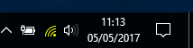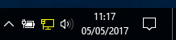

Select Open network and sharing centre
The Click on Set up a new connection or network
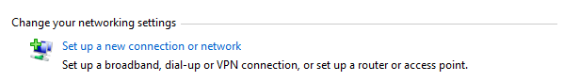

Choose Connect to a workplace
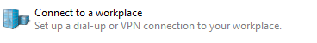
And click on next
Select Use my Internet Connection (VPN)
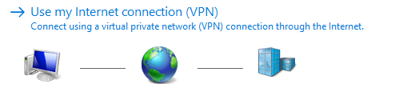

You will be presented with the following:
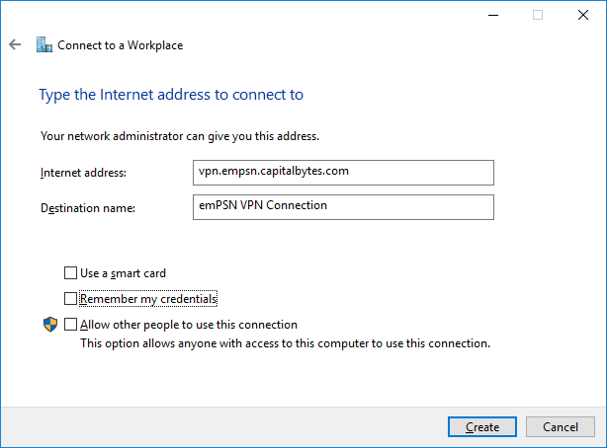
Enter the internet address vpn.empsn.capitalbytes.com
Enter the destination name, this can be anything such as emPSN VPN or MySchool VPN
Un‐Tick all boxes and click Create
The VPN dialer will be created, this needs to be edited before it can be used.

Right click your network icon (shown highlighted in Yellow – wifi and wired connection)

Select Open network and sharing centre
Select Change Adapter Settings
Select the VPN Dialer just created - such as emPSN VPN or MySchool VPN
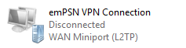
Right click the connection you have just made and select properties
The VPN Connection properties will appear
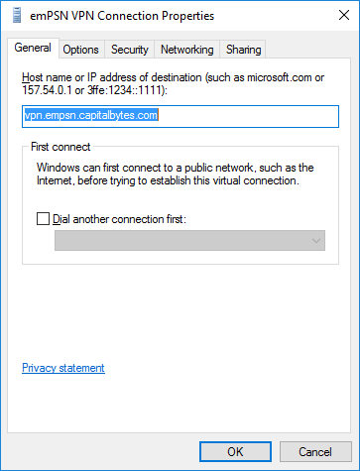

Select the Options Tab
Click PPP Settings and ensure Enable LCP extensions is ticked.
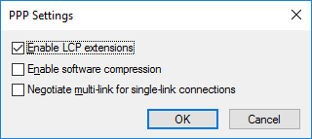
Click OK

Select the Security Tab
Under Type of VPN Select Layer 2 Tunnelling Protocol with IPSec (L2TP/IPSec)
Under Data encryption select Require encryption (disconnect if server declines)
Click Allow these Protocols
Check Challenge Handshake Authentication Protocol (CHAP)
Check Microsoft CHAP Version 2 (MS-CHAP v2)
Click Advanced Settings
Check Use pre-share key for authentication
Type in the pre‐shared key you have been given – this is personal to your connection
Click OK on Advanced Properties
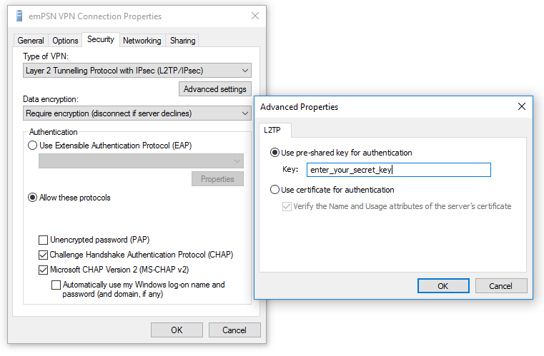

Select the Networking Tab
Untick Internet Protocol Version 6 (TCP/IPv6)
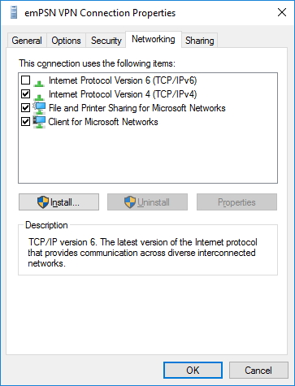

Select the Sharing Tab
Defaults should be as shown
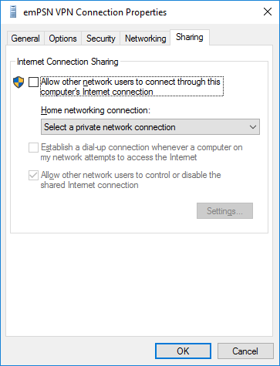

Click OK to close and accept the Connection Property changes
Close Network Connections Control Panel.
Configuration is now complete and you will be able to use the VPN dialer.

Usage - Connecting
Left click your network icon (shown highlighted in Yellow – wifi and wired connection)

And Select the VPN Connector created - such as emPSN VPN or MySchool VPN
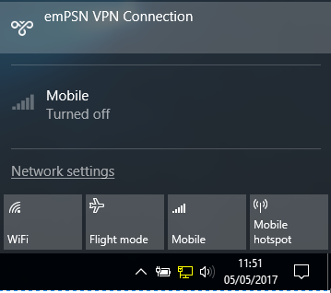
A settings window will appear, Select the VPN Connector created - such as emPSN VPN or MySchool VPN
Click Connect
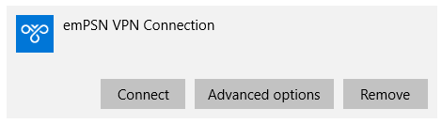
Enter the username and password details for the VPN service – personal to you

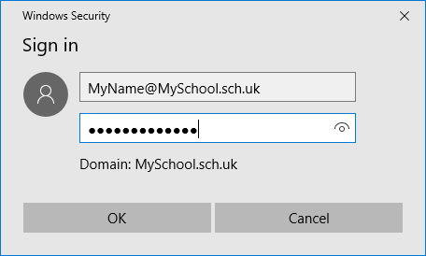

Your details will be verified and checked
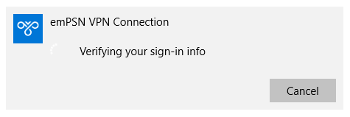

Once you are connected the connection box will change
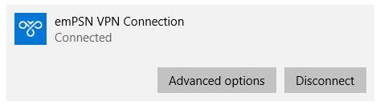

Usage - Disconnecting
When you have finished with your remote access simply Left click your network icon (shown highlighted in Yellow – wifi and wired connection)

And Select the VPN Connector created - such as emPSN VPN or MySchool VPN
A settings window will appear, Select the VPN Connector created - such as emPSN VPN or MySchool VPN
Click Disconnect

Changing VPN Passwords
Your VPN username and Password are personal to you. To change your VPN password
Goto URL - https://vpn.capitalbytes.com
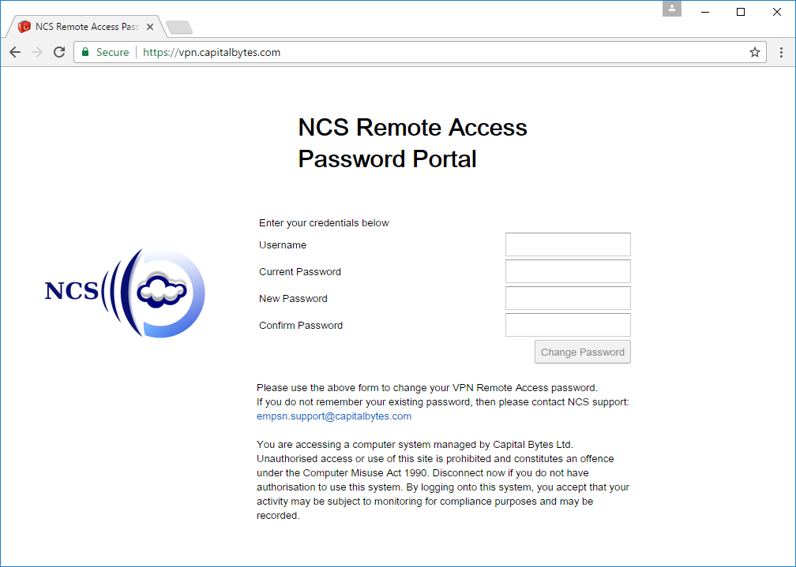

Enter your Username, Current Password, New Password and Confirm Password
Click Change Password
Your Password has been changed

Please use a complex password or pass phrase, so your password is not easy to guess.

If your username and/or password is not correct or do not match you will be prompted - Invalid username or password
When you password change is successful you will be prompted - Password has been changed successfully!

